My finding: https://www.youtube.com/watch?v=Wt_0QgLLvjY

1. Deal before changes--->TFSB0073deal after changes done--->TFSB0073  
   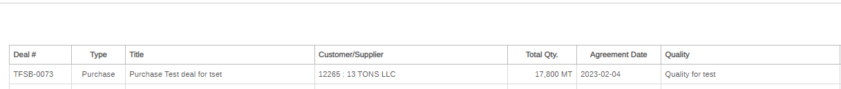  
   Changes updating nicely only
2. All the buttons r in disabled mode for adding  NEW STRIP in the existing deal TFSB-0073  & data is not moving from product section(Manage deal page)  i,e-->Product &Product Quality in the STRIP INFO Section(ManageStrip) 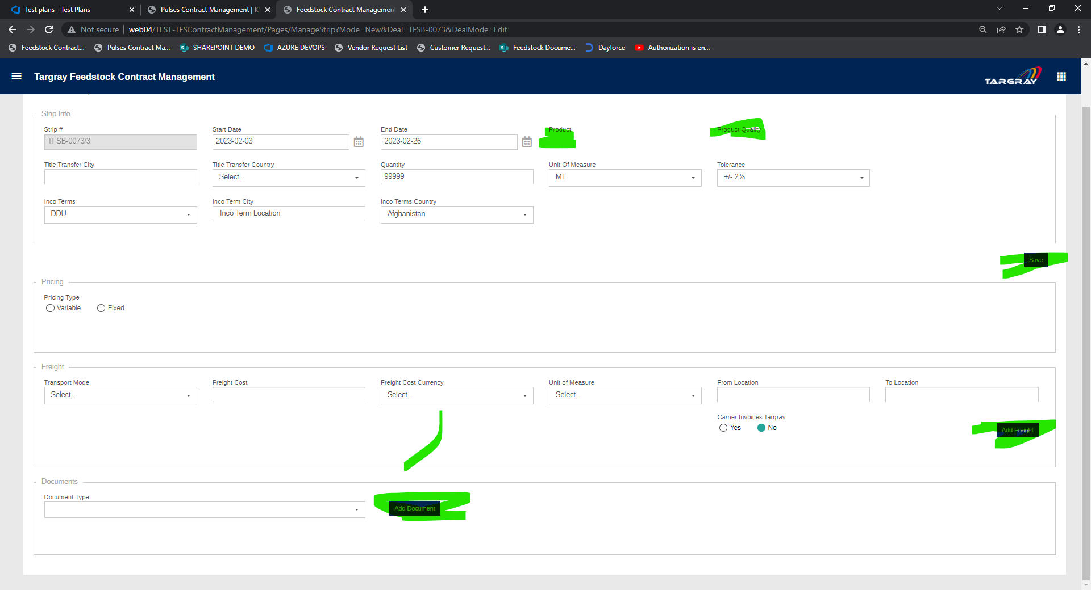
3. when i cloned a STRIP then UPDATE STRIP button is in disabled mode --->TFSB-0073/2A screenshot of a computer

   Description automatically generated
4. please check broker name is different i think I am not sure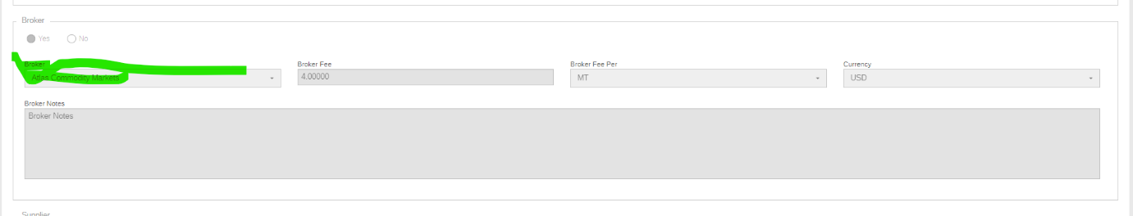Graphical user interface, text, application

   Description automatically generated
5. I am not able to publish the deal when i am clicking on PUBLISH button refreshing  but not showing as  published (no popup msg displayed on top)
6. when i am cloning a strip its again duplicating the DEAL also & that means whole deal & strip r cloning--🡪Deal number TFSB-0073 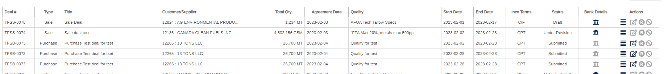

THIS AFTER r2 revison but new strip Unit of Measure is CBM but IT IS displaying old strip’s Unit of Measure after revision & quantity is combing all the strip”s values & displaying as TOTAL addition

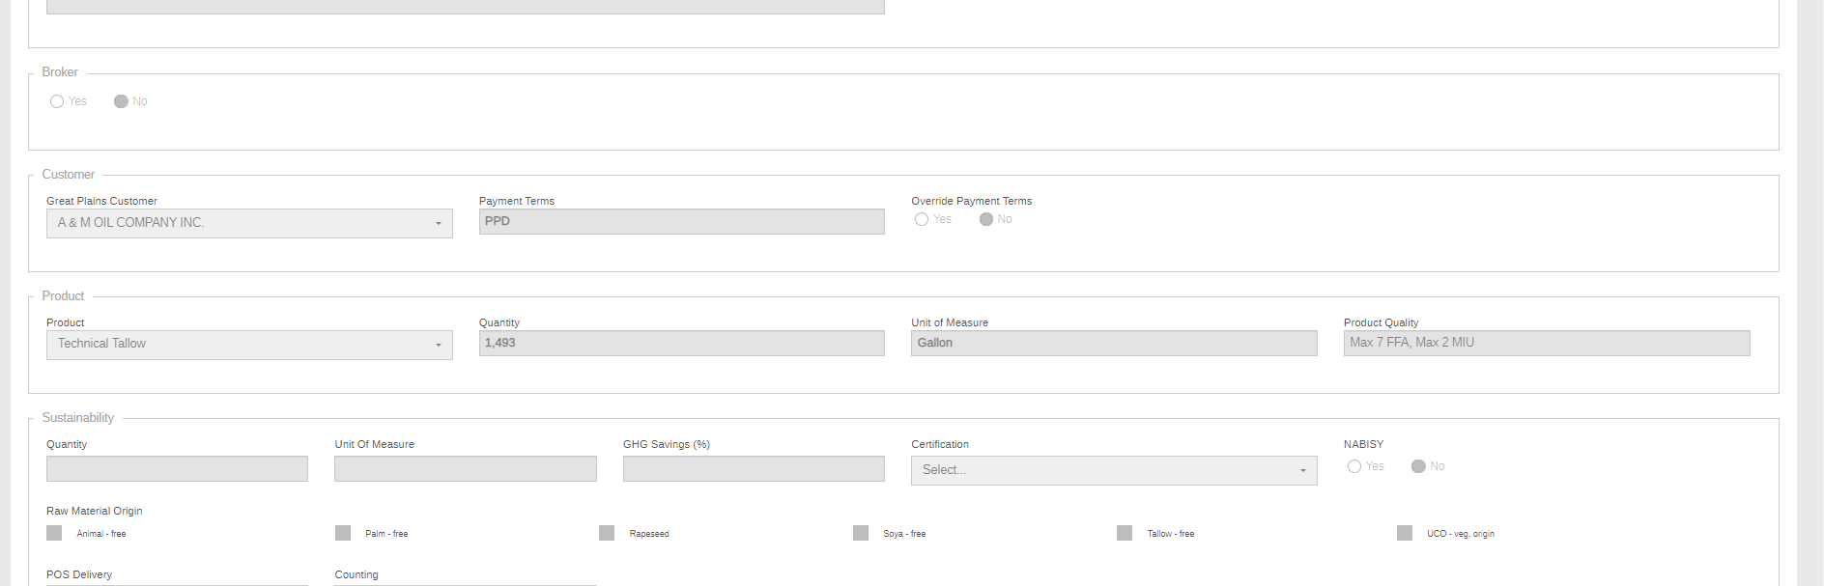

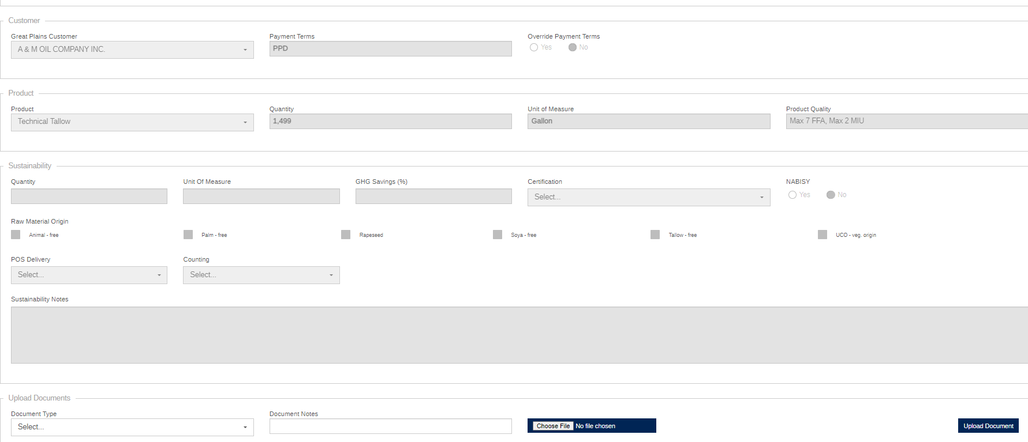

BOFAUS6S Bank of America financial center is located at 150 Broadway New York, NY 10038 Bank of America